Module 4 Linux Essentials   
TASK 4.3

After you have logged into the system, do the following.   
1.Invoke pwd to see your current working directory (there should be your home directory).

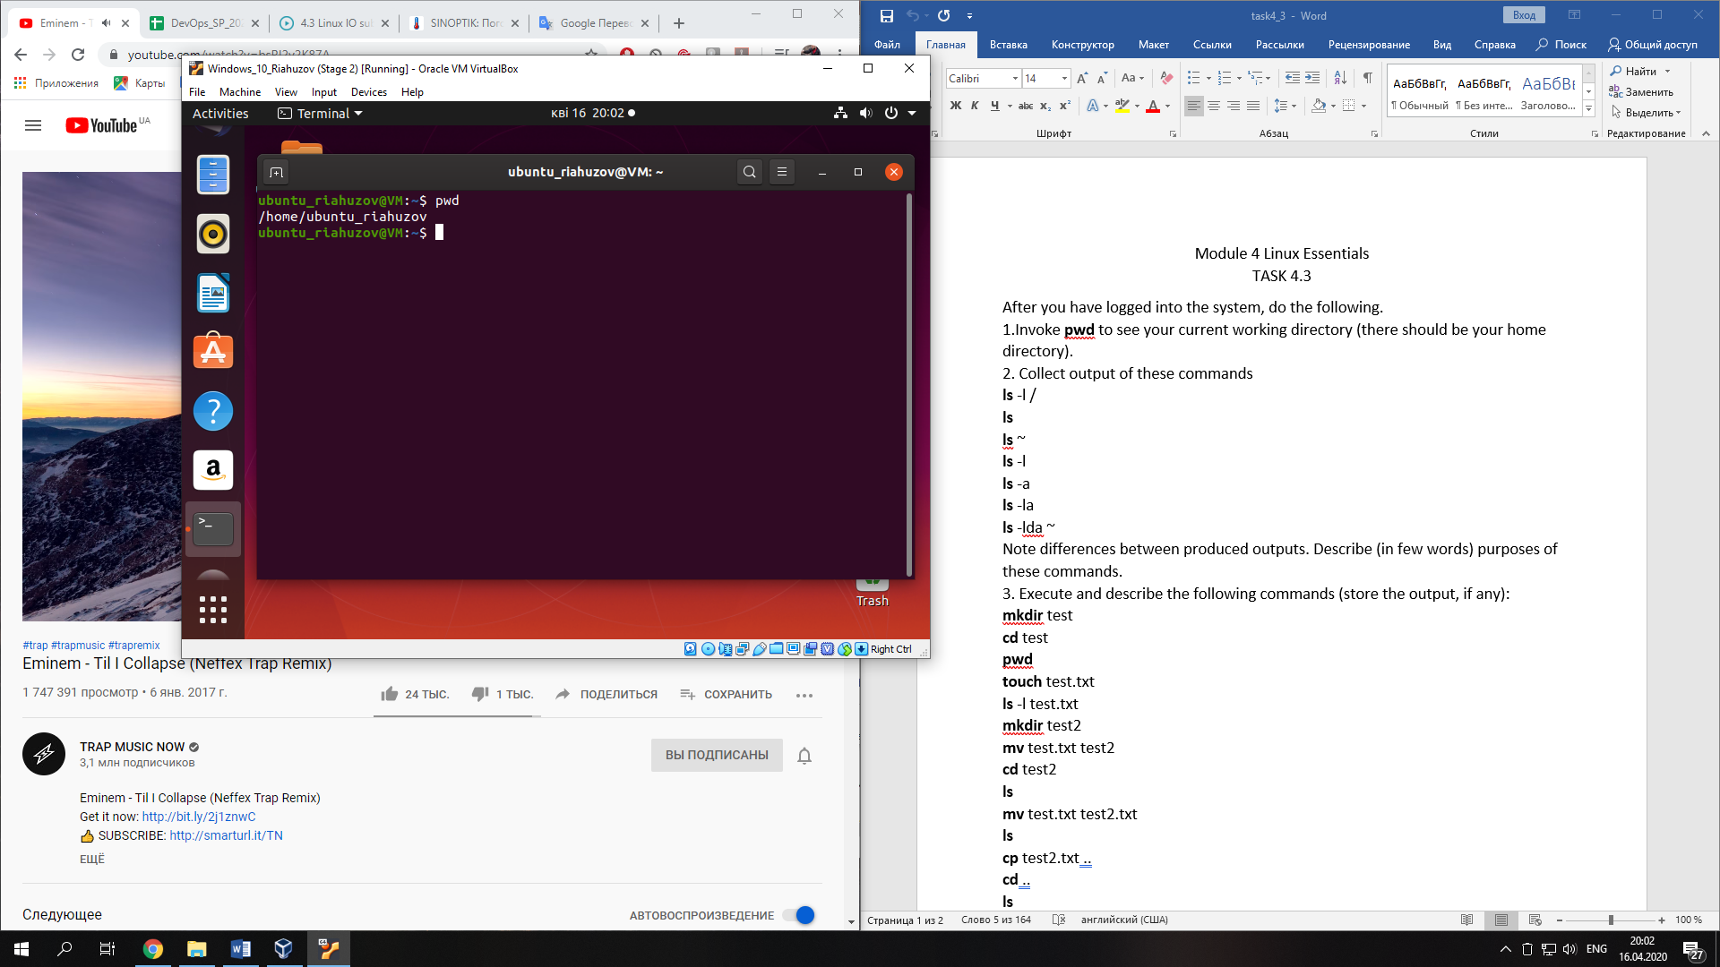  
2. Collect output of these commands   
ls -l /   
lsls ~   
ls -l   
ls -a   
ls -la   
ls -lda ~   
Note differences between produced outputs. Describe (in few words) purposes of these commands.

These commands show us content of different directory (root, home or currently directory). The flags of this command help show all files or the long format of this files or information about the directory.

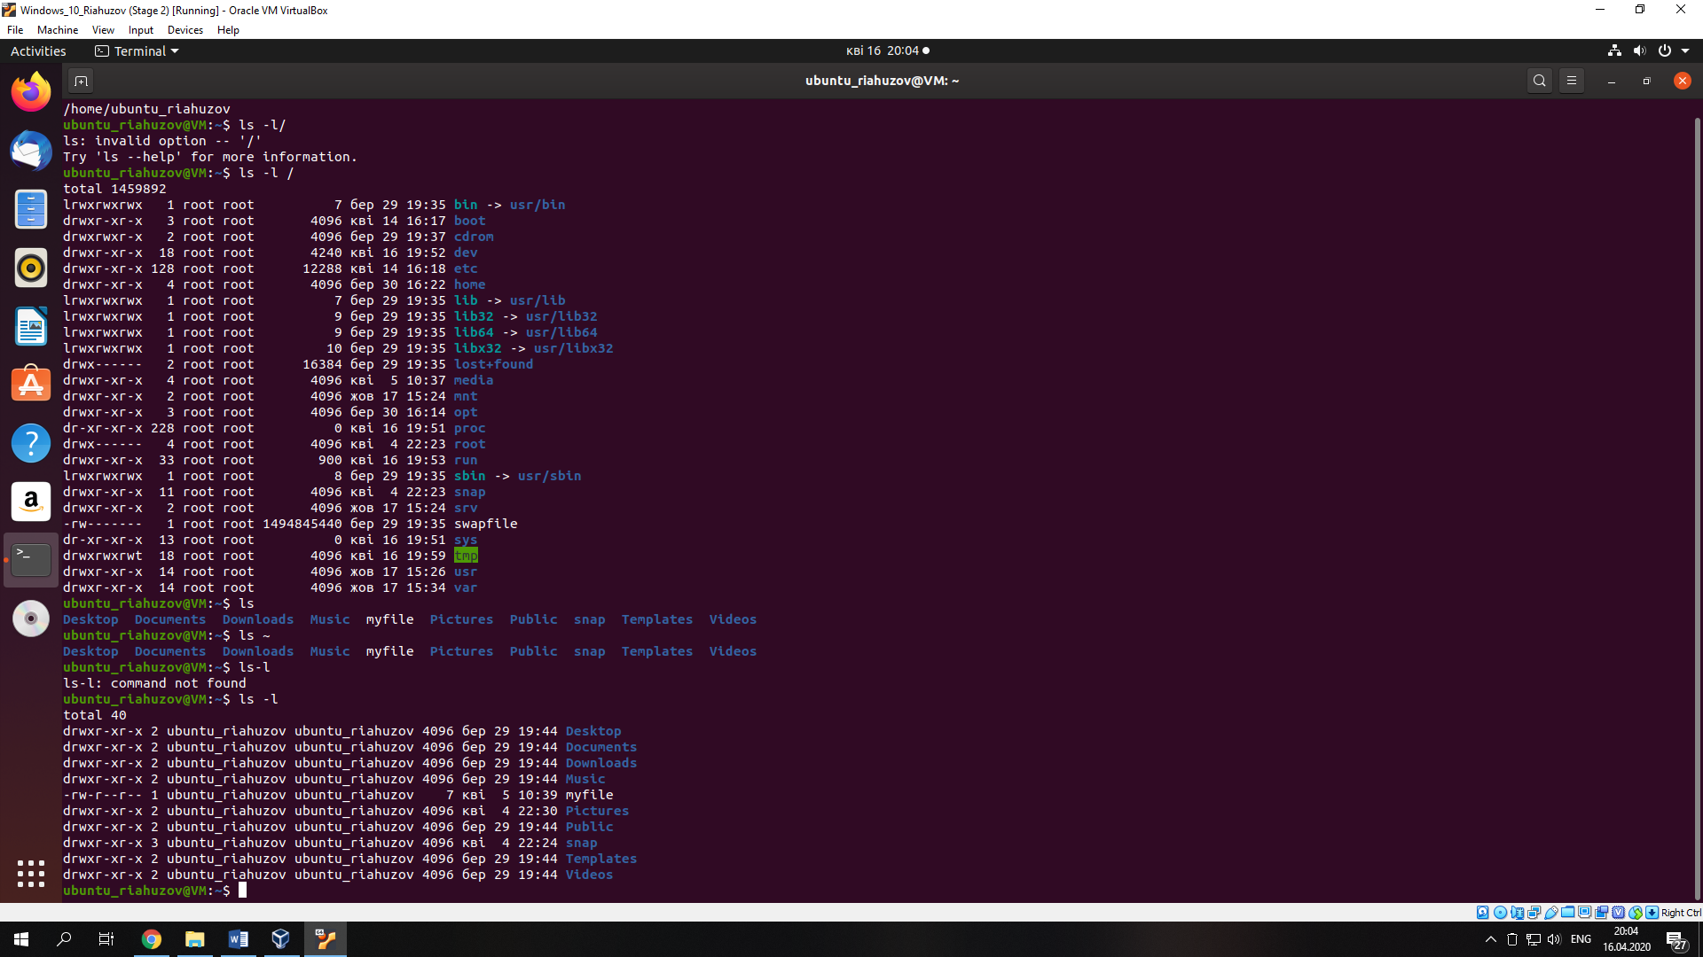

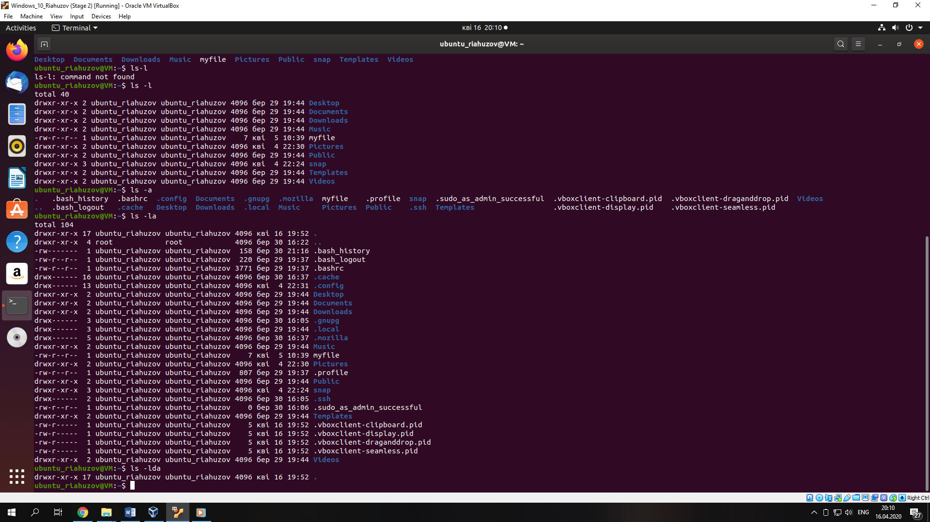  
3. Execute and describe the following commands (store the output, if any):   
mkdir test   
cd test   
pwd touch test.txt   
ls -l test.txt   
mkdir test2   
mv test.txt test2   
cd test2   
ls mv test.txt test2.txt   
ls cp test2.txt ..   
cd ..   
ls rm test2.txt   
rmdir test2

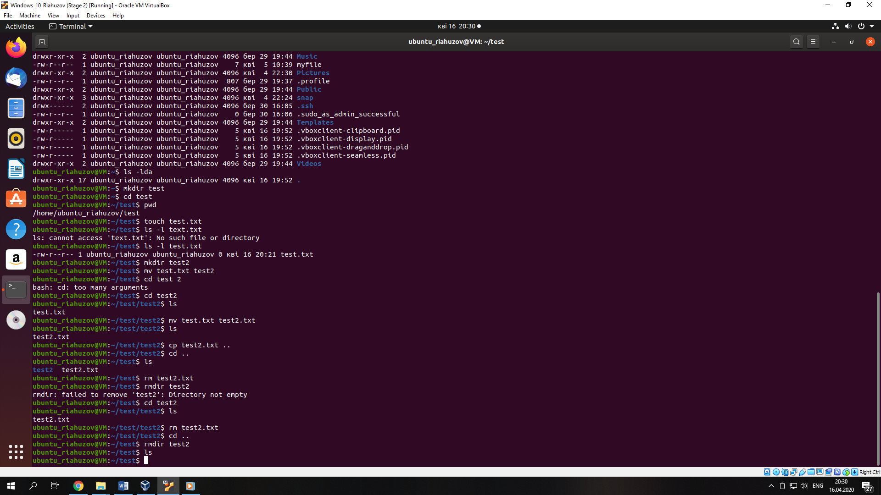

Create directory -> change directory -> check directory -> create file (text.txt) -> check file -> create new directory -> move file in new directory -> change directory -> check file in new directory -> rename file (text2.txt) -> check new name of file -> copy file in upper directory -> change directory -> check files in upper directory -> remove copied file (test2.txt) -> remove directory (test2)  
4. Execute and describe the difference   
cat /etc/fstab   
less /etc/fstab   
more /etc/fstab

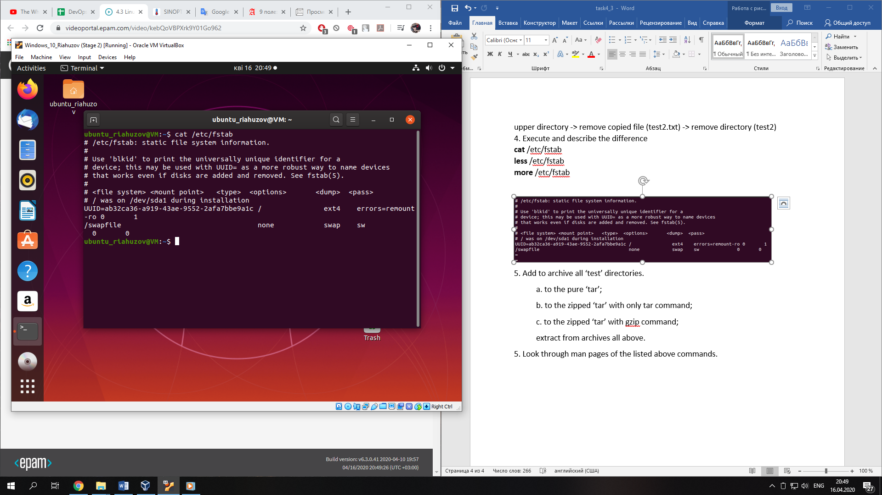

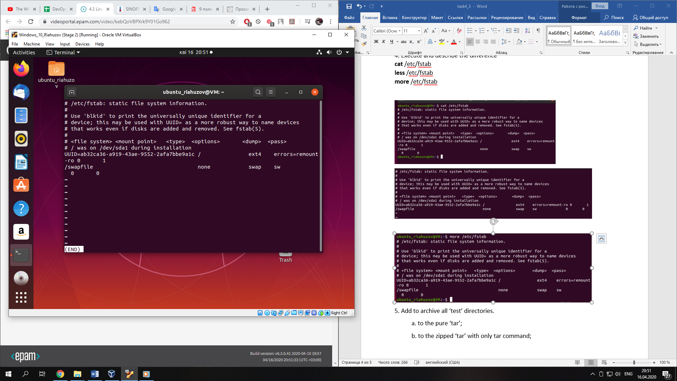

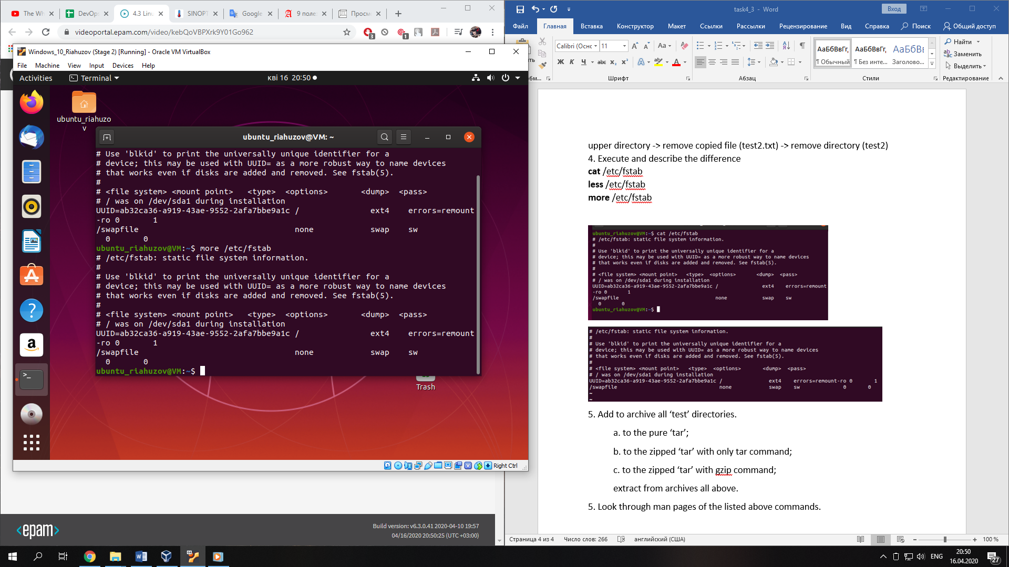

Command cat can show one or more text files in full screen mode. The more command can turn pages forward. The less command much more developed command. This command can turn pages forward or back and search for the required string.

5. Add to archive all ‘test’ directories.

a. to the pure ‘tar’;

b. to the zipped ‘tar’ with only tar command;

c. to the zipped ‘tar’ with gzip command;

extract from archives all above.

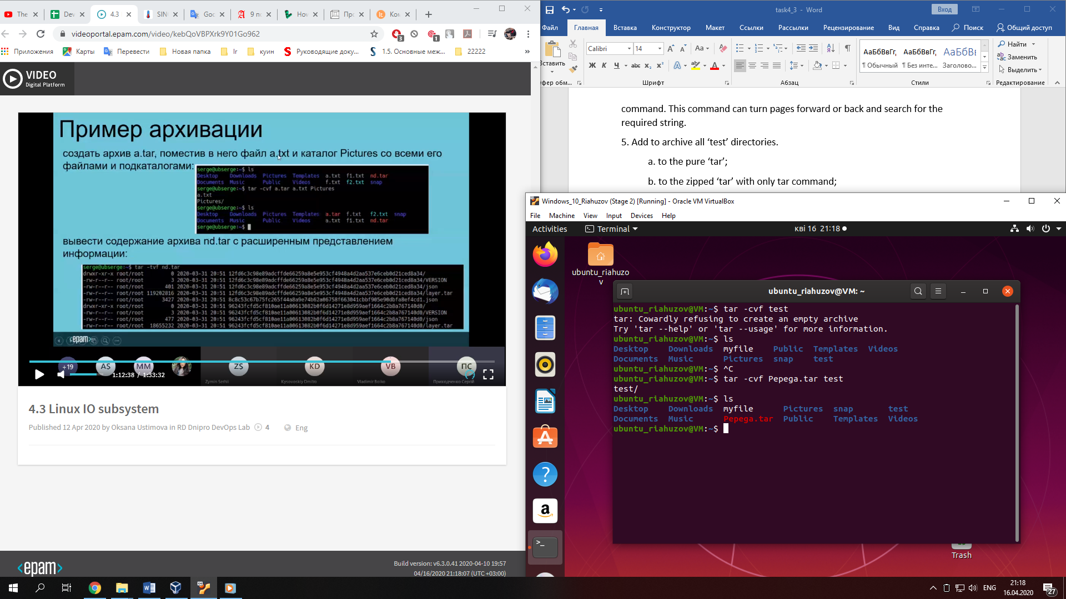

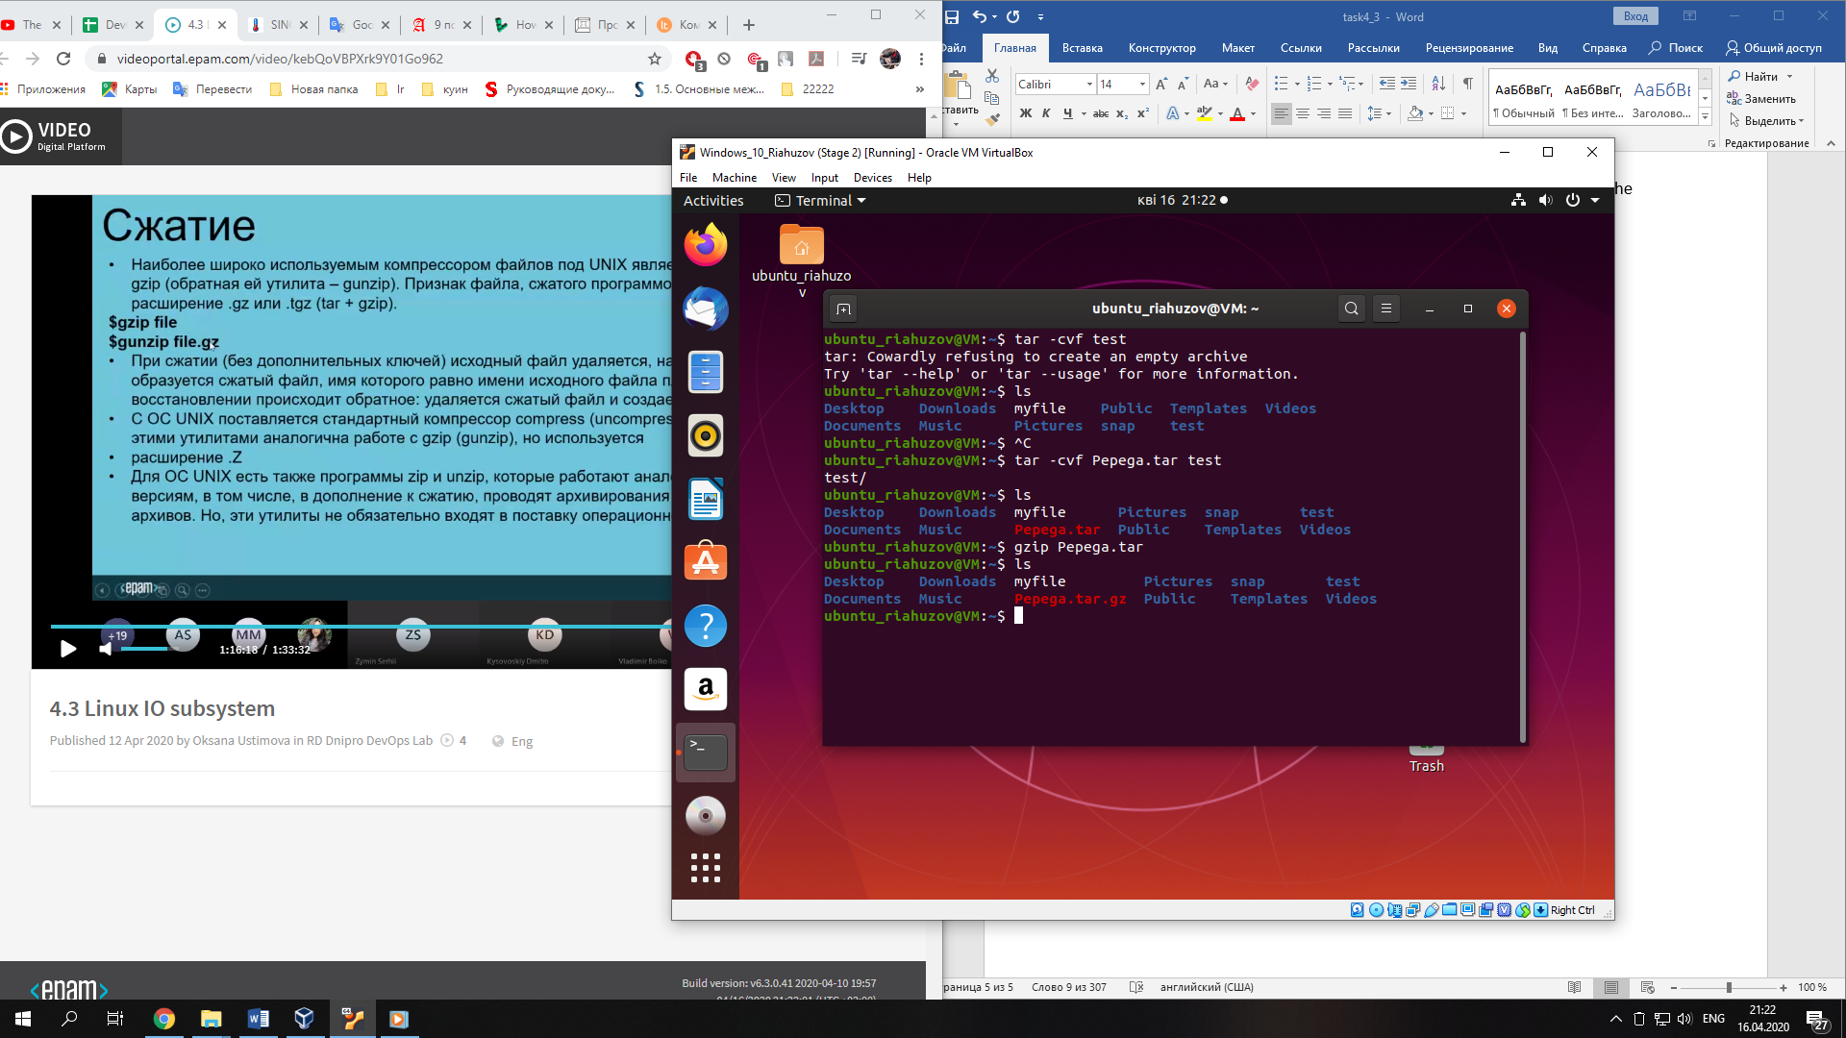

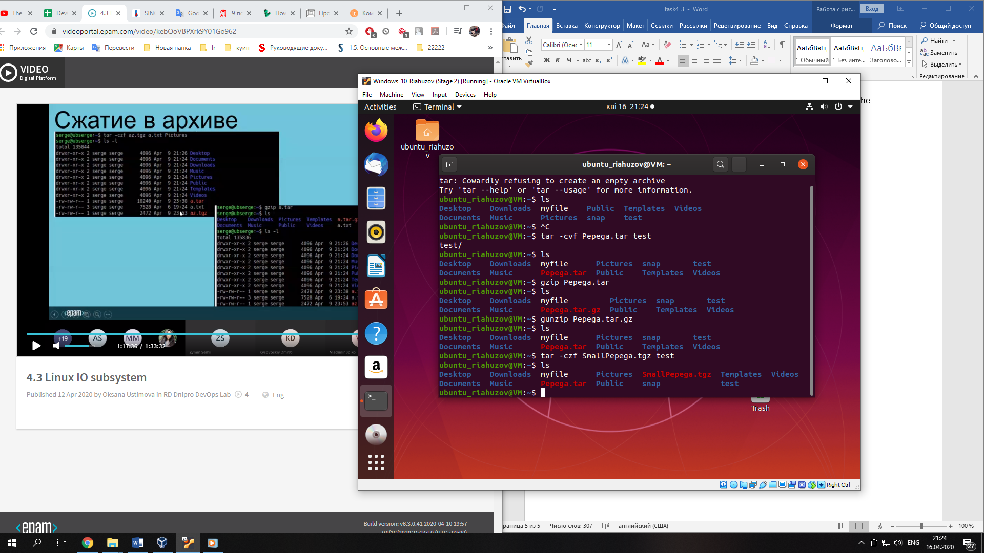

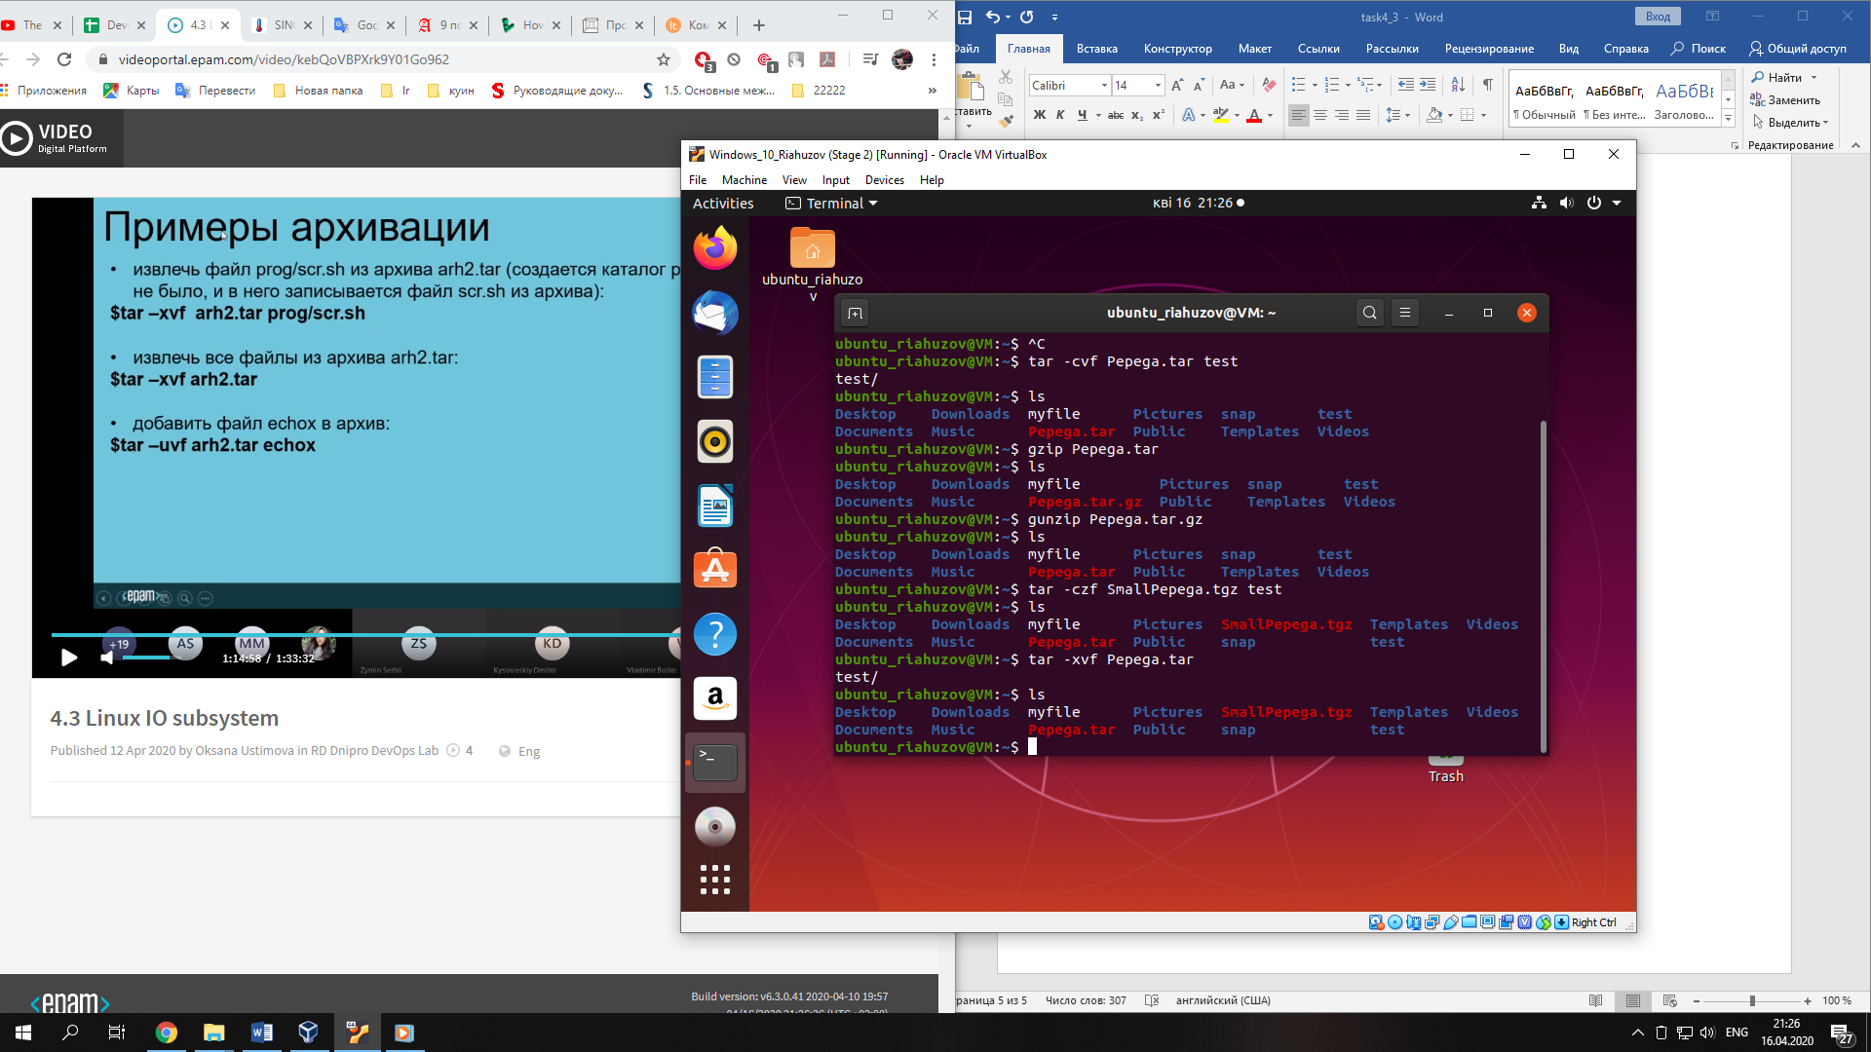

5. Look through man pages of the listed above commands.